

Big O Notations
Mathematical way of describing limiting behaviors of a function

Expression of the most inneficient way a program can function
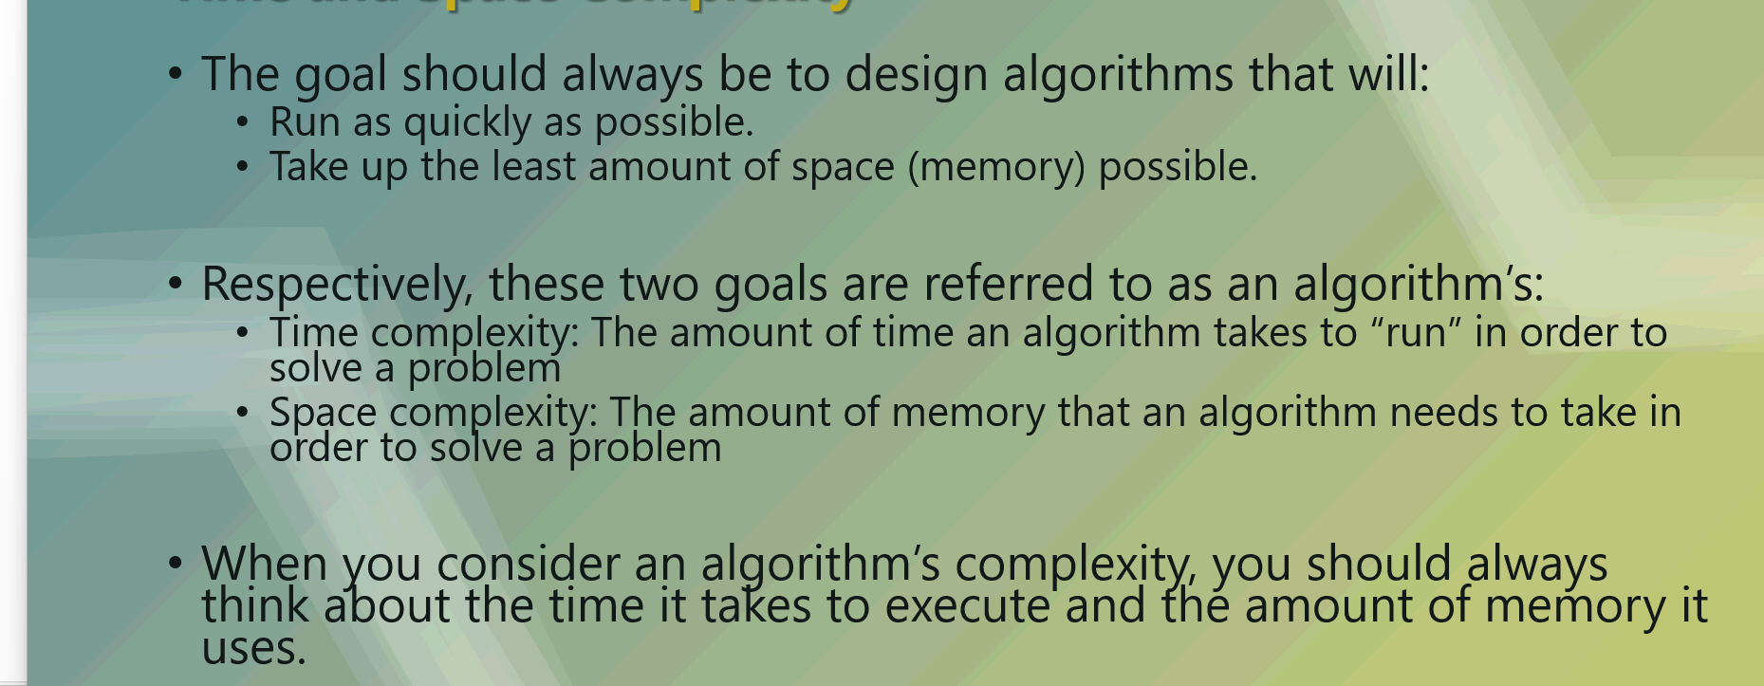
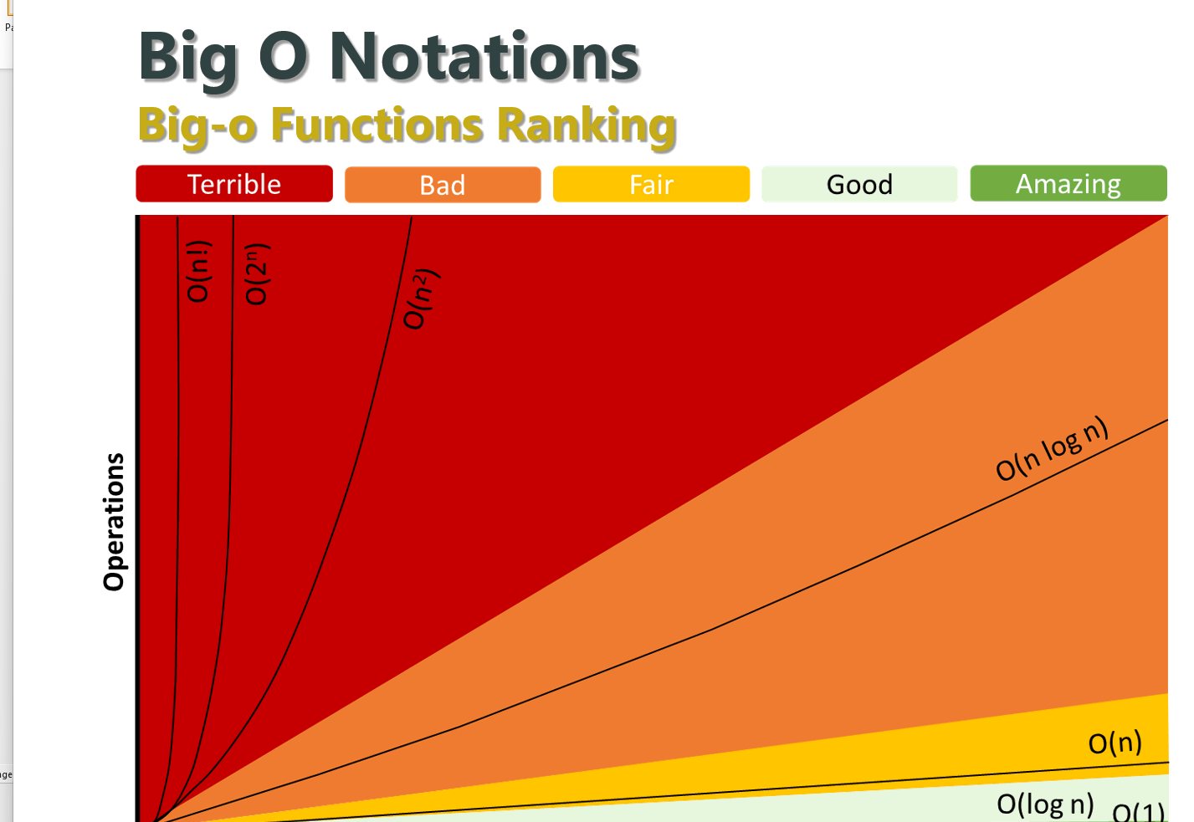

Constant complexity: No matter how big the input, the execution time will be the same
Logarithmic: Time is directly impacted by how big the input size is, (Example, binary search)
Linear: Time is directly proportional to how big the input size is (Simple loops)
Polynomial: Time directly proportional to square of the input. Something about nesting
Exponential: Time doubles with each item. Not input size, just each item.
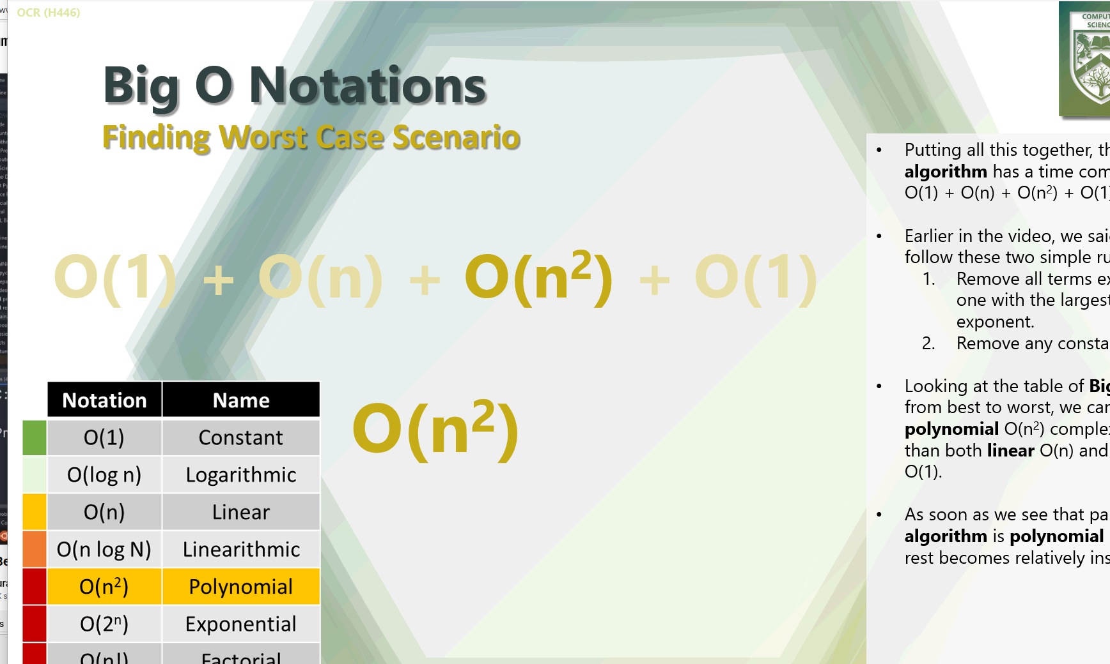

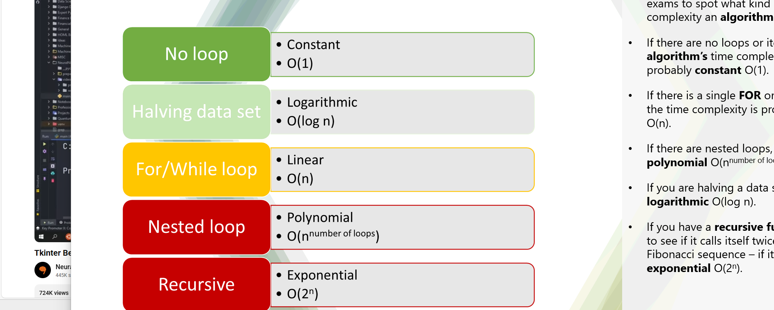
Merge sort = O(log(n))
Nested loop = O(n)

Merge sort:
Divide and conquer
Works best with large data sets
Parallel processing

Quick sort:
Divide and conquer
More efficient than merge sort
Ideal for parallel processing environments

Dijkstras shortest path:
Follows every single vertex, making it less efficient

A* Algorithm:
More optimal pathfinding than Dijkstra’s algorithm,
Used in gaming for pathfinding.
Uses heuristics
Heurtistics:
Estimated distance of the remaining distance to the goal
Underestimate, Far less efficient
Overestimate, the algorithm doesn’t work
In a map, Points are placed down on the map for ai to follow, on an x y scale
Manhattan Heuristic = Change in X + Change in Y
Euclidean Heuristic = Pythagoras

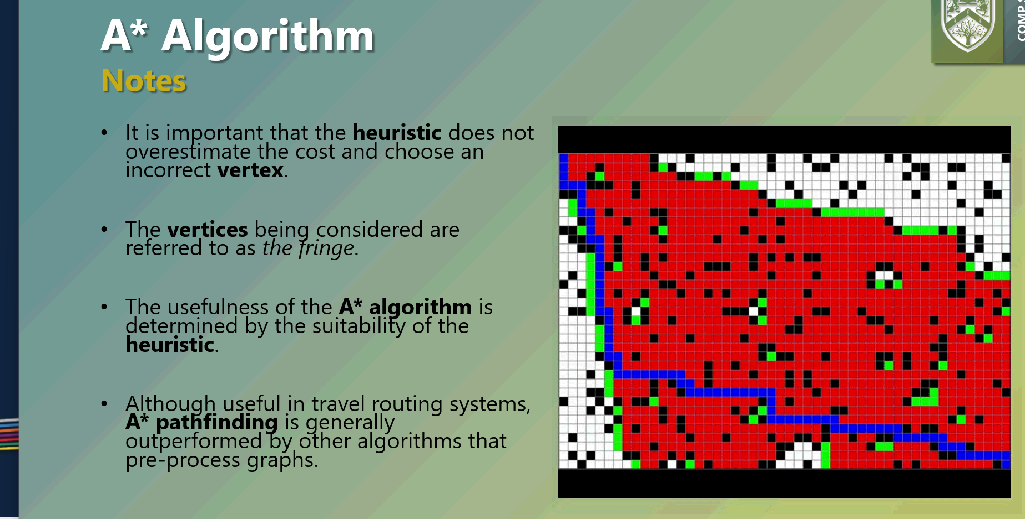
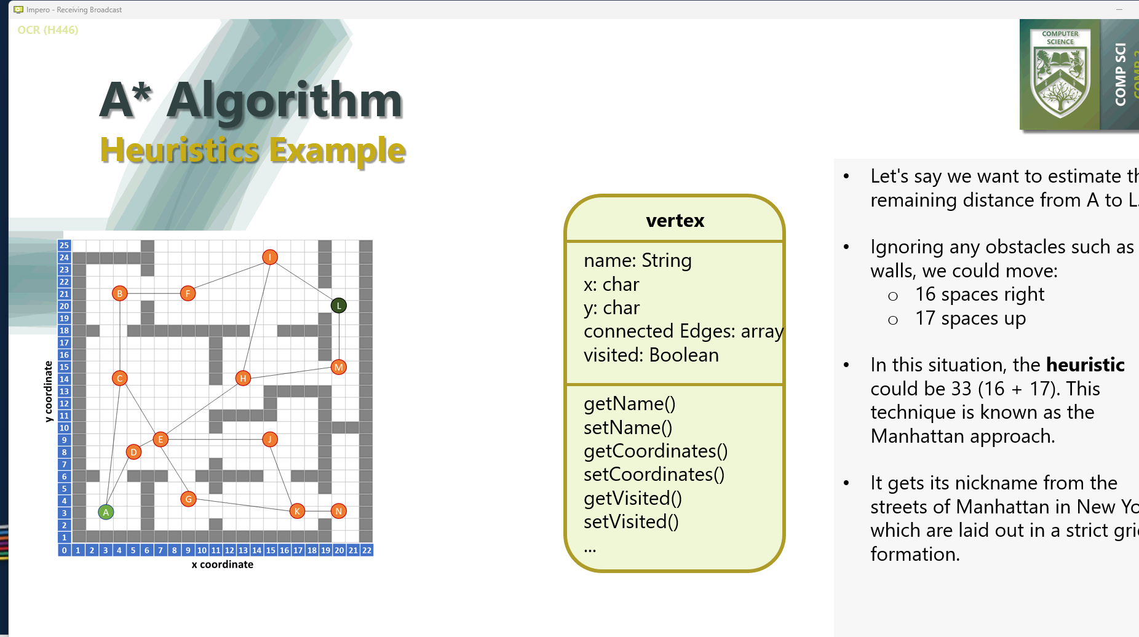

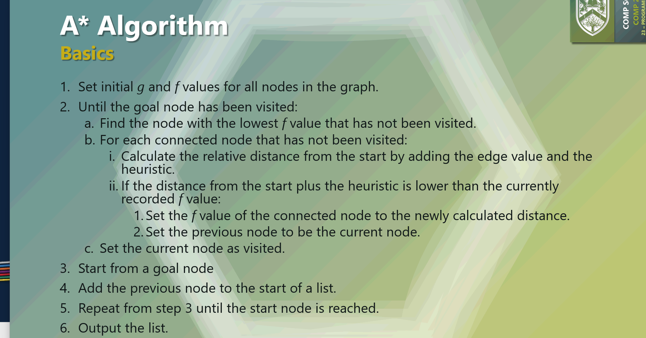

Binary trees stored as arrays
